EMERGENCY ACTION PLAN
Amon Carter-Riverside High School
3001 Yucca Ave.
Fort Worth, TX 76111

Purpose of this Emergency Action Plan:
The purpose of this document is to provide instructions to members of the Amon Carter-Riverside High School Athletic Department in the event of a medical emergency regarding student-athletes or individuals attending an athletic practice or event. A medical emergency includes the following situations:
- Unconscious athlete
- Persistent chest pain or difficulty breathing
- Suspected head, neck or spine injury
- Fractures that can’t be transported in any other vehicle other than an ambulance
- Severe bleeding that can’t be controlled or stopped
- Seizures
- Any other circumstance in which responders don’t feel comfortable in handling

Training Session(s) and EAP Review:
CPR/AED/basic first aid training will be provided free of charge by the Athletic Trainer at the end and/or the beginning of every school year. All coaches, band directors, cheerleading and drill team sponsors are required to have this training before they can supervise a practice or contest. These persons may also receive training via other sources at their own expense. Documentation of certification must be provided to the Athletic Trainer. The Emergency Action Plan will be reviewed at the beginning of each academic year. Coaches should discuss the policy with the Athletic Trainer during their CPR/AED and basic first aid training session.

Personnel:
Those with the highest level of health training are responsible for the emergency plan at a session or event.

Chain of Command during severe or catastrophic injury will be as follows:
- Team Physician (if present)
- Will be present at every varsity football home game
- Will be organized and provided by the home team Athletic Trainer
- FWISD Athletic Trainer
- Will be present or available by phone at all practices or contests conducted on campus
- If, for some reason, the Athletic Trainer can’t be immediately present, the coaches will be notified prior to the event occurring
- If multiple events are occurring on campus the Athletic Trainer will notify the coaches, administrator and security where they will be.
- Sports or activities with a higher risk of injury will take priority
- Basketball and soccer games held at a FWISD central site will have an FWISD Athletic Trainer providing medical coverage
- If multiple injuries occur at the same time they will be triaged and handled from worst to least life-threatening

- Coaching Staff
- Will be the first responder until the Athletic Trainer arrives
- Each coach is required to have the Emergency Information pages at every practice and game for each athlete present
- Other support staff (police officers acting as security, coaches from other schools, student athletic trainers, school nurse, spectators/attendees who are licensed or certified medical professionals)

Roles of the Emergency Team:
- Immediate care of the athlete
The first and most important role is immediate care of the athlete. Acute care in an emergency situation should be provided by the most qualified individual on the scene (see Chain of Command). Individuals with lower credentials should yield to those with more appropriate training.
- Emergency Equipment Retrieval
The second role, equipment retrieval, may be done by anyone on the emergency team who is familiar with the types and location of the specific equipment needed. Student athletic trainers, managers, coaches, or even players may be called on for this role. Important emergency equipment is noted below.
- Activation of Emergency Medical Services
The third role, EMS activation, should be done as soon as the situation is deemed an “emergency” or “life-threatening” event. Time is the most critical factor. Activating the EMS system may be done by anyone on the team. However, the person chosen for this duty should be someone who is calm under pressure, who communicates well, and who is familiar with the location of the sporting event. STEPS FOR ACTIVATION ARE NOTED BELOW.
- Directions to the emergency site
After EMS has been activated, one member of the team should be responsible for meeting the emergency medical personnel as they arrive at the site of the event, if they are not already there. An assistant coach or student athletic trainer is appropriate for this role.

Equipment Retrieval:
The majority of emergency equipment will be under the control of the Athletic Trainer. If the Athletic Trainer is not on site then a designee will be responsible for knowing where the emergency equipment is located and how to get to it. Emergency equipment listed below will be in designated locations during practices and competitions.

AUTOMATIC EXTERNAL DEFRIBRILLATOR (AED)
- Athletic AED is located inside the training room. It is located above the trainers’ desk on a shelf to the right of the computer. Rights to keys into the training room are pending, so the AED will be made a available according to schedules.
  - Athletic AED will be with the Athletic Trainer when covering events on or off campus
- Campus AED is located in the nurse’s office and in the second floor copier room.
  - Game Administrator is responsible for bringing Campus AED to the gym for events then returning it afterwards if a FWISD athletic trainer is not on location, the head coach and game administrator will be notified if this will be the case.
- Band AED is located in the band director’s office.

Emergency Communication:
Activation of Emergency Medical Services (EMS)
In the event that an emergency occurs at a practice or event, a member of the Emergency Team should promptly contact Emergency Medical Services (EMS). The local emergency telephone number is 911. Coaches are responsible for having a cellular phone in case of emergency.

Contacting the Emergency Medical Services (EMS)
- If EMTs are at the event, then a signal (determined in advance) should be given to summon them.
- If EMTs are not on site, call 911.
- The following information should be provided to the dispatcher:
1) Location (Be as specific as possible and use directions specified below)
2) Chief complaint and incident type?
3) Approximate age?
4) Conscious: Yes / No. . . or alert?
5) Breathing: Yes / No. . . or difficulty?
6) Is there chest pain?
7) Is there severe bleeding (spurting)?
8) What care is being given to the athlete
- Notify the Athletic Trainer, if not on site.
- As EMS is being dispatched, make sure someone is designated to retrieve any needed emergency equipment.
- Have the coaches serve as crowd control and keep other athletes away from the victim.
- Send someone to meet the ambulance at the designated entrance and direct to the parking area.
- If a parent/guardian is not present, a member of the coaching staff will accompany the injured athlete to the hospital.
- Get the athlete’s Emergency Card to take to the hospital.
- After EMS has been activated, a coach or administrator will contact the parent/guardian or emergency contact, if they are not present.
- Notify the following people that an emergency event has occurred: Head Coach (if not present), Principal (Assistant Principals if he is unreachable), Kevin Greene (Assistant Athletic Director), Mark Bethany (for situations involving AED usage, spinal injuries, or any time an ambulance is called to the scene or used)

CONTACT LIST (Keep this list confidential and do not freely circulate)
TITLE | NAME | CELL | OFFICE
Athletic Trainer | Shauna Woody | (817) 694-2225 | (817) 838-1523
Principal | Gary Ruthart | (817) 706-0585 | (817) 814-9000
Assistant Principal | Steve Jones | (817) 692-5550 | (817) 814-9012
Assistant Principal | Jennifer Orona | (817) 300-9444 | (817) 817-9014
Assistant Principal | Irma Natoli | (682) 554-2317 | (817) 814-9013
Boy’s Coordinator | Jim Jeffries | (832)528-2704 | (817) 838-1523
Girl’s Coordinator | Aimee Petersen | (817)715-3205 | (817) 838-1500
Emergency Preparedness Coordinator | Mark Bethany | (817) 822-4275 | (817) 814-2673

Directions to Possible Emergency Sites:

- Football Practice Field, Field House/Training Room, New/Outside Gym, Weight Room, Old/Upstairs Gym, and Band Hall. Enter through the access road located on 3301 Yucca Ave. by the front parking lot. Proceed north to breezeway in front of band hall. Personnel (Certified/Licensed Athletic Trainers, Student Trainers, Coaches, Security, and Administrators) will be situated at various locations for directing EMS to scene. To enter the New Gym, entrance is accessible from the south, north, and west side of the building. To enter the Old Gym, access is available through the east side door of the school located next to the cafeteria. The band hall is located directly north of the parking lot entrance.
*If the breezeway area is blocked for entrance to the football practice field/weight room/field house/training room/upstairs gym, use #2 as an alternate route.
- Baseball Field and Tennis Courts. Enter through student/coaches parking lot located on Gwynne St. and Eagle Dr. The entrance to the tennis courts is located on the east side of the courts next to the street. Gates to the baseball field are located in left field and next to each dugout.
- Football game field, soccer, track and field. Depending on closest entrance to the athlete, a) direct EMS to enter through access road to field located on Gwynne St. and Eagle Dr., or b) direct to Riverside Middle School (1600 Bolton St) and proceed through front parking lot on south side to football/soccer field behind middle school. In case gates are locked, locate nearest coach, trainer, administrator, or security to unlock the gates.
- Softball field. Enter through north parking lot of Riverside Middle School (1600 Bolton St.) and proceed east through gates to softball field. Gates are located next to each dugout.

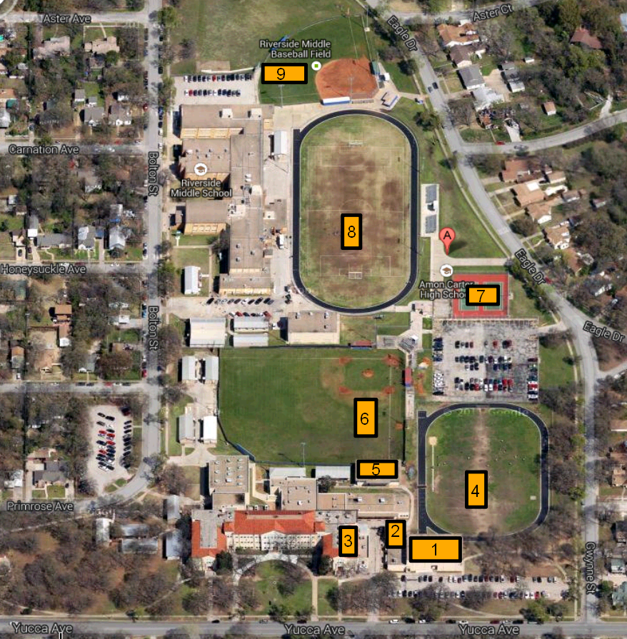Key:
- New Gym
- Weight Room
- Upstairs Gym
- Football Practice Field
- Training Room/Field House
- Baseball Field
- Tennis Courts
- MS Football/Soccer Field
- Softball Field
Weather Related Emergencies:

The FWISD Weather Safety Procedures will be followed for all athletic practices and events. These procedures are included in the FWISD Athletic Department Coaches Handbook. All coaches, band directors, and sponsors are responsible for knowing and following these procedures, especially those regarding heat and lightning.

Evacuation Areas:

- Lightning
- For outdoor practices, all participants will be moved indoors
- For outdoor events, the home team will go to the field house.
- The visiting team will go a designated locker room in the field house or their busses.
- The Game Administrator or a coach will inform the spectators that the teams are leaving the field due to lightning in the area and they should vacate the stands and wait in their vehicles.
- All indoor activities will remain inside until it is safe according to the Weather Safety Procedures
- Hail or Severe Storm
- For outdoor practices, all participants will be moved indoors
- For outdoor events, the home team will go field house
- The visiting team will go to a designated locker room in the field house.
- The Game Administrator will inform the spectators that the teams are leaving the field due to hail or severe storm activity in the area and they should vacate the stands and wait in their vehicles.
- All indoor activities will remain inside until it is safe according to the Weather Safety Procedures
- Tornado
  - If games are outdoors and the sirens go off, if at all possible send everybody to the front hall on the first floor. If you feel you cannot make it into the school safely, take shelter in the field house. Safest spot in the field house would be the soccer/baseball storage with no outside access and just one door to close.
  - If your are inside, make to the first floor in front hall or either side hallway away from doors and glass.
- Cold Weather
  - Please see Cold Weather Practice Recommendations suggested by the Athletic Department

- Heat Index Policy
  - At this current time, all outside activity is stopped when in local heat index reads 105 degrees. Please see the FWISD Athletic Policy of Heat Index for further questions.
  - Measures should be taken to make sure breaks are taken and adequate cooling time is provided when temperatures are extremely hot.

Concussion Policy:

Due to the recent trends and studies regarding the dangers of post-concussion syndrome and second impact syndrome, FWISD Athletic Department is implementing recommendations from physicians at John Peter Smith health systems in treating athletes’ who sustain a head injury during practice or games.

Any athlete that suffers an injury resulting in any signs or symptoms listed below will be removed from further participation for the remainder of the game or practice.

Concussion signs observed by staff: | Concussion symptoms reported by athlete:
Losses consciousness (even temporarily) | Headache
Appears to be dazed or stunned | Nausea or vomiting
Unsure of game score or opponent | Balance problems or dizziness
Lack of coordination | Double or fuzzy vision
Poor reaction time | Sensitivity to light or noise
Shows behavior, mood or personality change | Feeling sluggish
Forgets events prior to injury | Feeling foggy
Unequal or dilated pupils | Concentration or memory problems
Bleeding or clear fluid coming from nose or ears | Lightheadedness
 | Confusion

Athlete’s that have been removed from competition must be cleared by a physician and/or the Athletic Trainer. They must be cleared to begin the Return to play sequence and monitored closely during it. They must also be cleared after completing the Return to play sequence to return to full activity. If you have ANY questions regarding concussions, please take a look at the FWISD Concussion Protocol and or ask an/the athletic trainer

